SIMATS ENGINEERING
SAVEETHA INSTITUTE OF MEDICAL AND TECHNICAL SCIENCES
CHENNAI – 602105
Department of Computer Science and Engineering
Course Code: | DSA0502 | Course Title: | Query Processing for Data Science
CO Assessed: | CO5 | Assessment: | Tool 2– INDUSTRY PROBLEM SOLVING
Weightage: | 35% | Total Marks:
CO5 Statement: Create meaningful visualizations using Pandas and Matplotlib, including charts, distributions, relationships, and interactive visual representations for effective communication
Student Name: | Valli Karthik | Reg. No.: | 192324258
Section / Batch: | AI & DS | Date of Submission: | 17-08-2026
Faculty In-charge: | Dr. B.Shyamala Gowri | Project Mode: | Individual Submission

ASSESSMENT TOOL 1 – INDUSTRY PROBLEM SOLVING

Code of Conduct
I Valli Karthik (192324258) certify that this submission is my original work and that I have adhered to all guidelines specified for this assessment. I understand that any violation of academic integrity rules will result in disciplinary action.
Signature: V.Karthik….

- E-Commerce Sales Pattern Analysis
An e-commerce company has historical data containing date, product category, quantity sold, revenue, discount, and customer rating. Analyze the evolution of sales over time and identify relationships between discount, quantity, and revenue. Use appropriate bar charts, line charts, distribution plots, frequency plots, and scatter matrices to identify important business patterns.

Objective:
Create meaningful visualizations using Pandas and Matplotlib, including charts, distributions, relationships, and visual representations for effective communication.

Problem Statement
An e-commerce company has historical data containing date, product category, quantity sold, revenue, discount, and customer rating. The objective is to analyze sales over time and identify relationships between discount, quantity sold, and revenue using appropriate visualizations.

Objective
- Import the dataset using Pandas.
- Analyze sales trends over time.
- Compare revenue across product categories.
- Study the distribution of revenue.
- Examine customer rating frequencies.
- Identify relationships between discount and revenue.
- Use a scatter matrix to observe relationships among numerical variables.
Dataset Description
Column | Description
Date | Date of transaction
Product_Category | Category of product
Quantity_Sold | Number of products sold
Revenue | Revenue generated
Discount | Discount percentage
Customer_Rating | Customer rating

Methodology
- Load the CSV file.
- Convert the Date column to datetime format.
- Group revenue by month.
- Create a line chart for monthly revenue.
- Create a bar chart for category-wise revenue.
- Create a histogram for revenue distribution.
- Create a frequency bar chart for customer ratings.
- Create a scatter plot for discount versus revenue.
- Generate a scatter matrix.

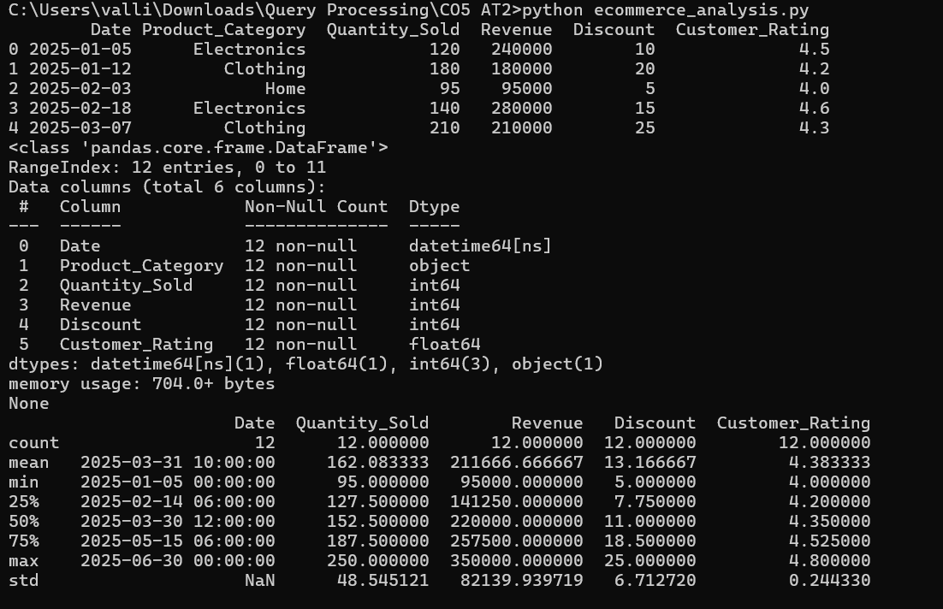
Visualizations Used
Visualization | Purpose
Line Chart | Monthly revenue trend
Bar Chart | Revenue by category
Histogram | Revenue distribution
Frequency Plot | Customer ratings
Scatter Plot | Discount vs revenue
Scatter Matrix | Relationships among variables

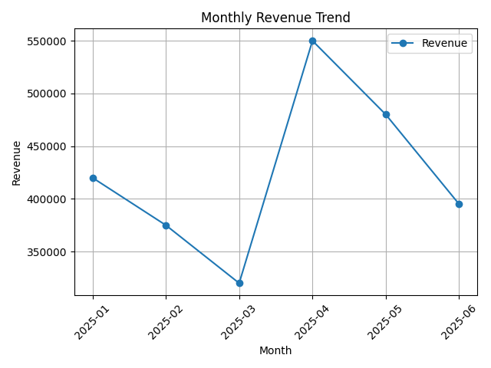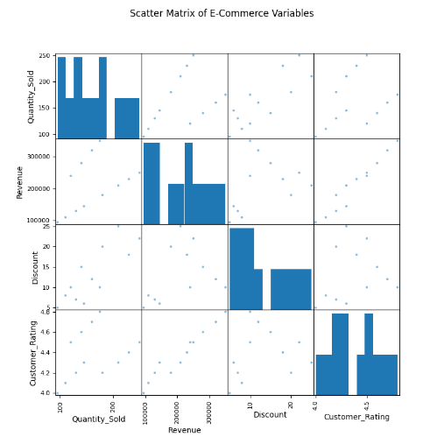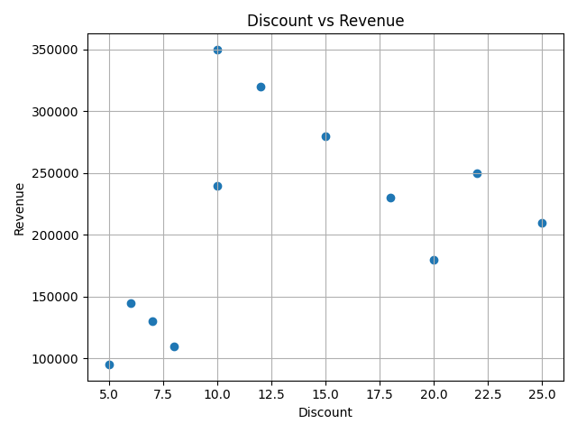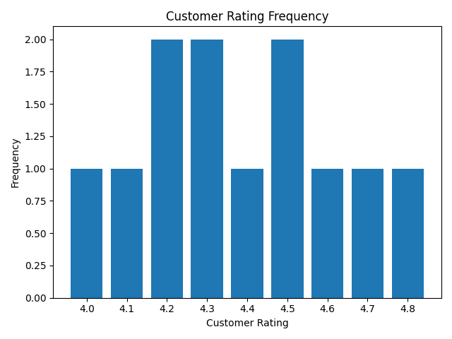

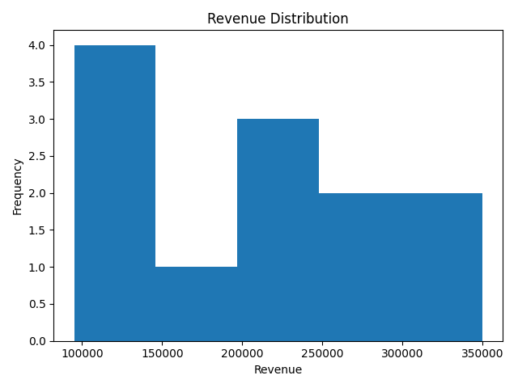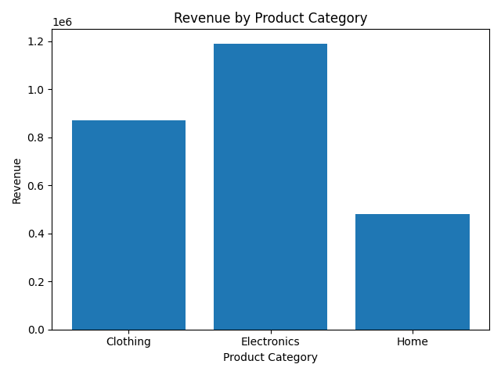

Result
The analysis shows how revenue changes over time, which product categories generate more revenue, and how discounts relate to revenue. The scatter matrix helps identify visible relationships among quantity sold, revenue, discount, and customer rating.

Conclusion
Pandas was used for data processing and Matplotlib for visualization. The generated charts effectively communicate sales trends, distributions, and relationships in the e-commerce dataset.

- Employee Productivity Analysis
An organization collects employee working hours, experience, salary, tasks completed, productivity score, and monthly performance. Import and analyze the data using Pandas. Visualize relationships between working hours, experience, and productivity; analyze distributions and frequencies; and use scatter matrices, lag plots, autocorrelation plots, and bootstrap plots to identify productivity patterns and variability. Provide data-driven recommendations to management.

Problem Statement
An organization collects employee data containing working hours, experience, salary, tasks completed, productivity score, and monthly performance. The objective is to analyze employee productivity using visualizations and identify relationships and variability.

Objective
- Import employee data using Pandas.
- Analyze the relationship between working hours and productivity.
- Analyze the relationship between experience and productivity.
- Study the distribution of productivity scores.
- Compare employee performance.
- Use scatter matrix, lag plot, autocorrelation plot, and bootstrap analysis.
Dataset Description
Column | Description
Employee_ID | Employee identifier
Working_Hours | Daily working hours
Experience | Years of experience
Salary | Employee salary
Tasks_Completed | Number of tasks completed
Productivity_Score | Productivity score
Monthly_Performance | Monthly performance score

Methodology
- Load the CSV dataset.
- Explore the data using head(), info(), and describe().
- Plot working hours against productivity.
- Plot experience against productivity.
- Create a histogram of productivity scores.
- Create a bar chart of monthly performance.
- Generate a scatter matrix.
- Generate a lag plot.
- Generate an autocorrelation plot.
- Perform bootstrap resampling of productivity scores.

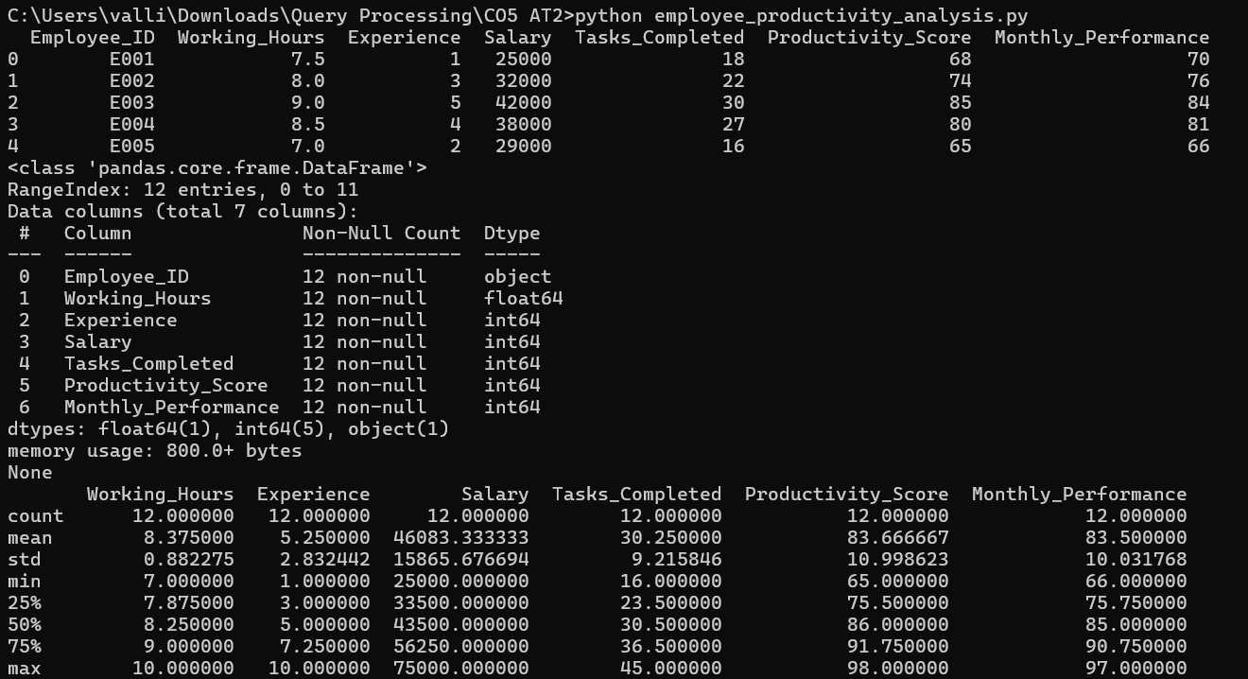
Visualizations Used
Visualization | Purpose
Scatter Plot | Working hours vs productivity
Scatter Plot | Experience vs productivity
Histogram | Productivity distribution
Bar Chart | Employee monthly performance
Scatter Matrix | Relationships among variables
Lag Plot | Dependence between consecutive performance values
Autocorrelation Plot | Correlation across lags
Bootstrap Histogram | Variability of mean productivity

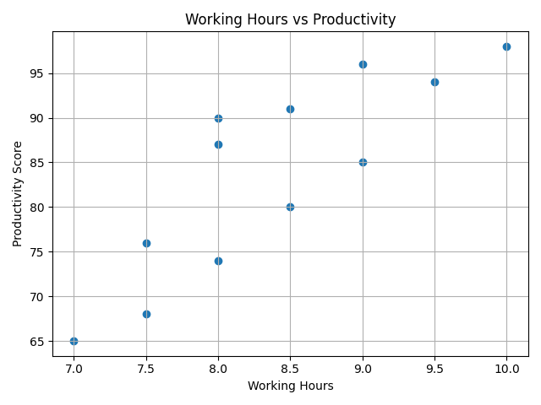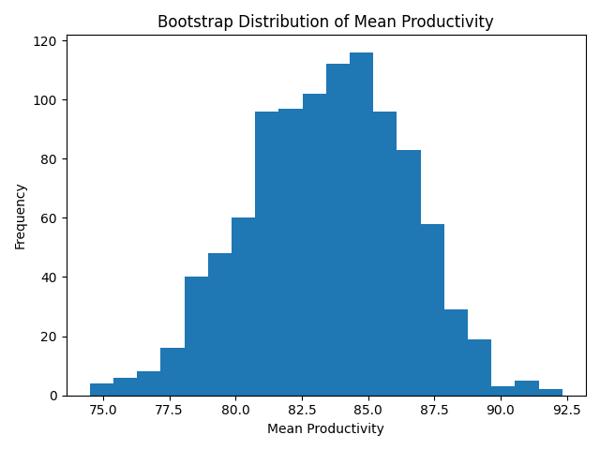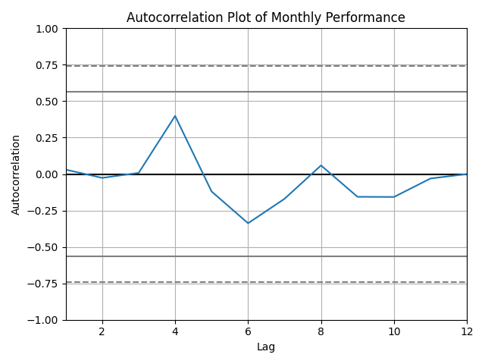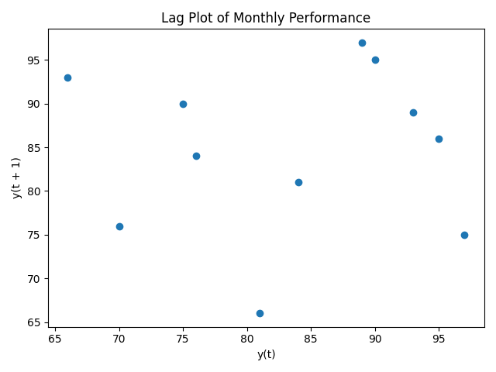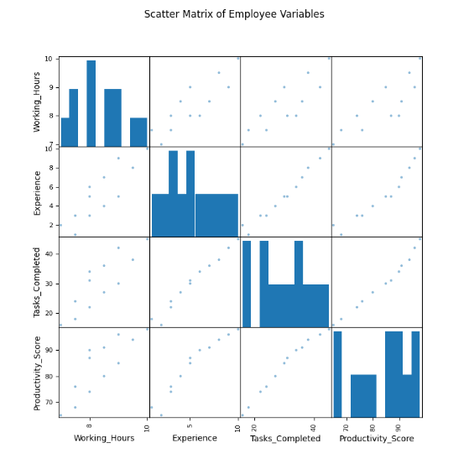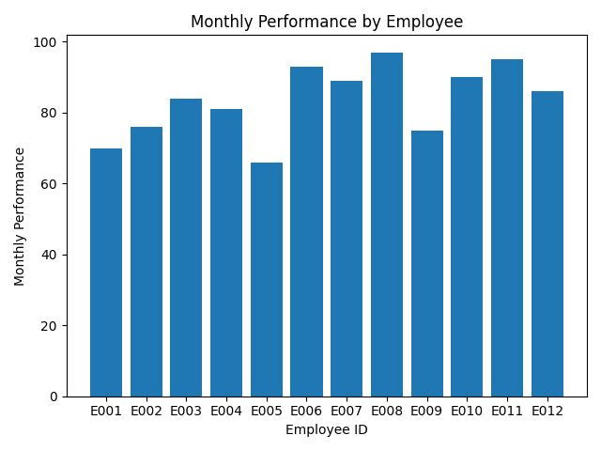
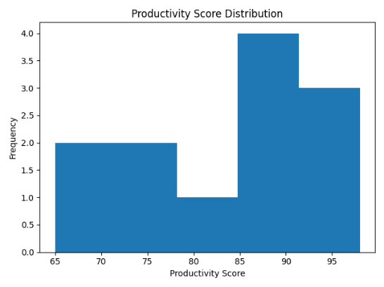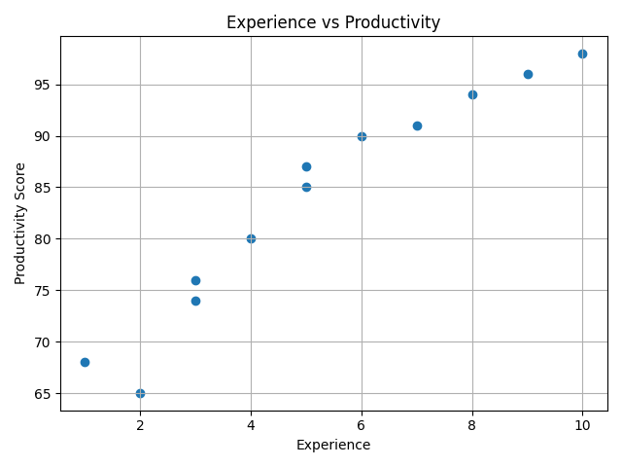

Result
The visualizations help identify how employee productivity relates to working hours and experience. The scatter matrix shows relationships among numerical variables, while lag and autocorrelation plots examine patterns in monthly performance. Bootstrap analysis estimates the variability of the average productivity score.

Conclusion
The employee productivity dataset was successfully analyzed using Pandas and Matplotlib. The visualizations provide meaningful insights into productivity patterns, relationships between employee characteristics, and the stability of performance measurements.

窗体底端

